Product Requirement Document (PRD): Student Wellness Journal

# 1. Overview

Product Name: Student Wellness Journal

Problem Statement: Students in India are facing increasing mental health issues due to academic pressure, limited support, and stigma. There is a lack of safe, reflective spaces to track and manage mental well-being.

Objective: Build a secure journaling web app enabling students to log their mood, visualize emotional trends, and stay motivated through quotes.

# 2. Team Information

|  |  |  |  |
| --- | --- | --- | --- |
| Name | Email | Registration No | Roles |
| Devjeet Chowdhury | 2023lm70004@wilp.bits-pilani.ac.in | 2023lm70004 | PM, Programmer, User Researcher, Tester |
| Sudhangini Sahu | 2023lm70006@wilp.bits-pilani.ac.in | 2023lm70006 | Programmer, Tester |
| Saurav Chandra | 2023lm70005@wilp.bits-pilani.ac.in | 2023lm70005 | Not available for project |
| Madasu Narendra | 2023lm70003@wilp.bits-pilani.ac.in | 2023lm70003 | Not available for project |
| Soumyajit Mishra | 2023lm70001@wilp.bits-pilani.ac.in | 2023lm70001 | Not available for project |

# 3. Features

|  |  |
| --- | --- |
| Feature | Description |
| Authentication | Login/Register using ASP.NET Identity |
| Journal Entry | Log daily moods (with emojis) and optional journal text |
| Mood History | View past entries in reverse chronological order |
| Analytics | Track mood trends with line/bar charts using Chart.js |
| Motivational Quotes | Random positive quotes shown on homepage |

# 4. Tech Stack

|  |  |
| --- | --- |
| Layer | Technology |
| Backend | ASP.NET Core (with Identity) |
| Frontend | Bootstrap + Razor Views |
| Database | SQL Server |
| Visualization | Chart.js |
| Hosting (optional) | Azure / Localhost |

# 5. Roadmap

|  |  |
| --- | --- |
| Week | Task |
| 1 | Project scaffolding + Identity setup |
| 2 | JournalEntry model + DB integration |
| 3 | Create/List journal entries |
| 4 | Mood input with emojis |
| 5 | Chart.js analytics |
| 6 | Random motivational quote integration |
| 7 | Final testing & deployment |

# 6. SDG Alignment

UN Goal 3: Good Health and Well-being

Target 3.4: Reduce mental health issues through early support.

In India, student suicides account for 7.6% of total suicides (NCRB 2022).

# 7. UML Diagrams

## Use Case Diagram

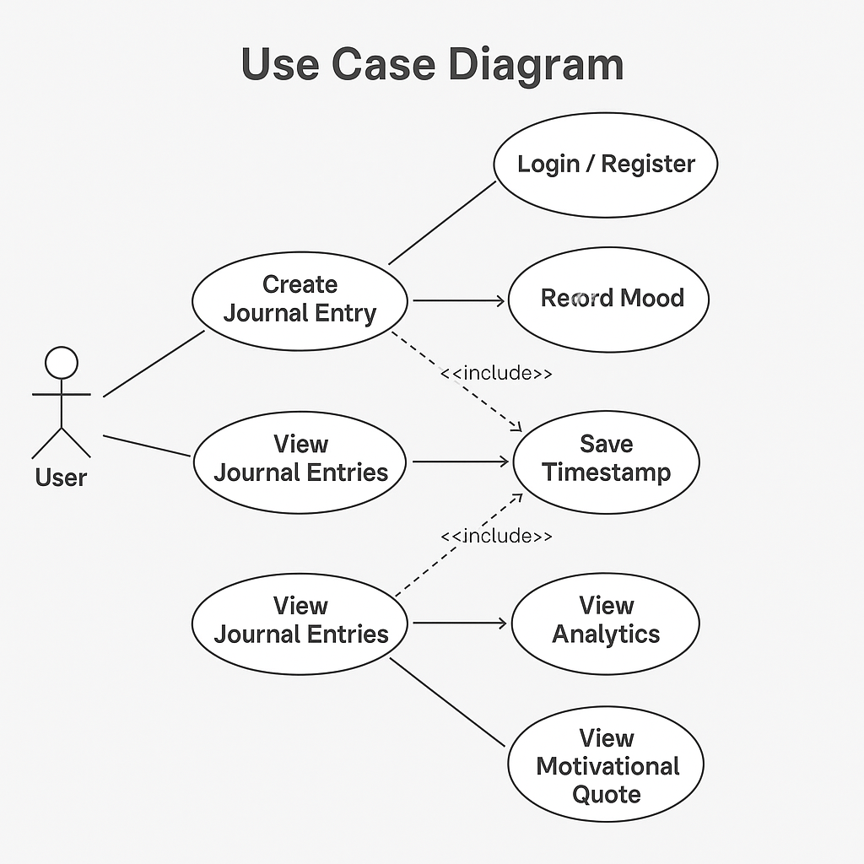

## Activity Diagram

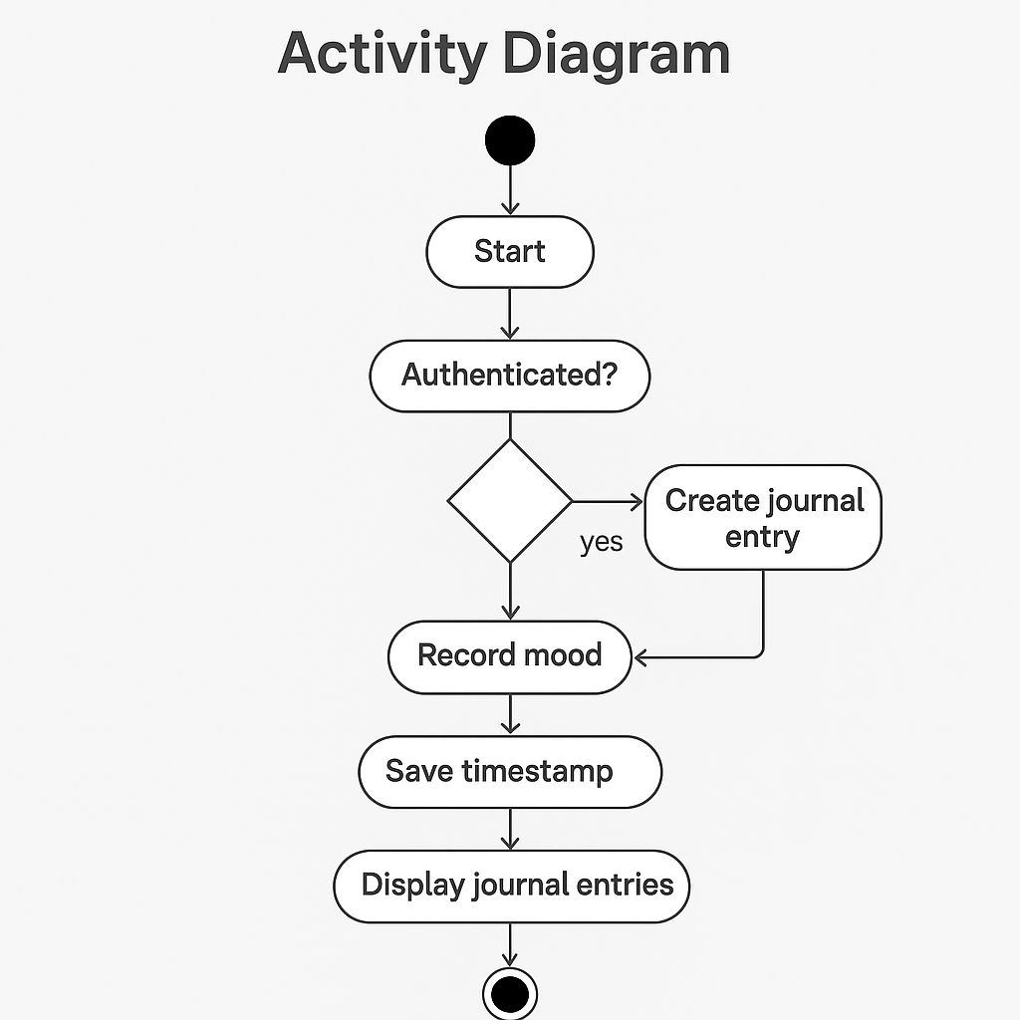

## State Machine Diagram

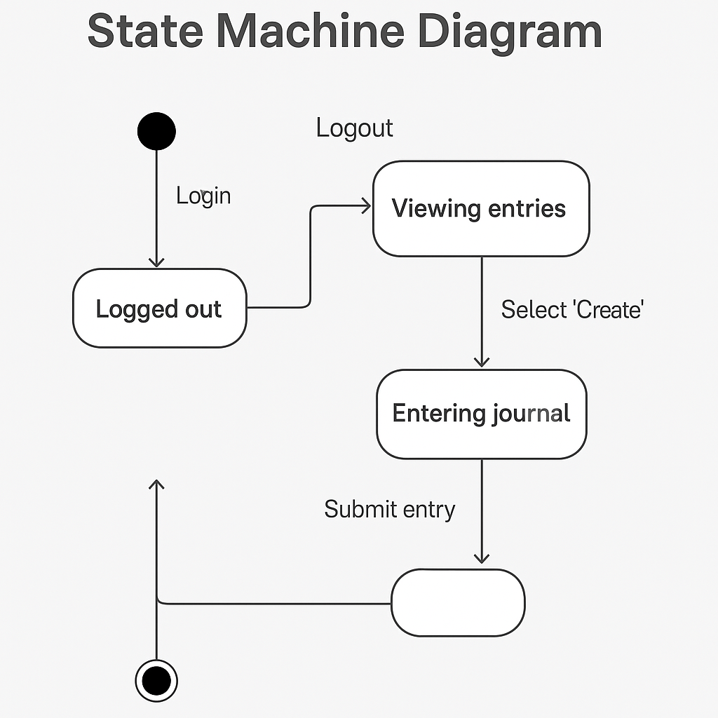

## Sequence Diagram

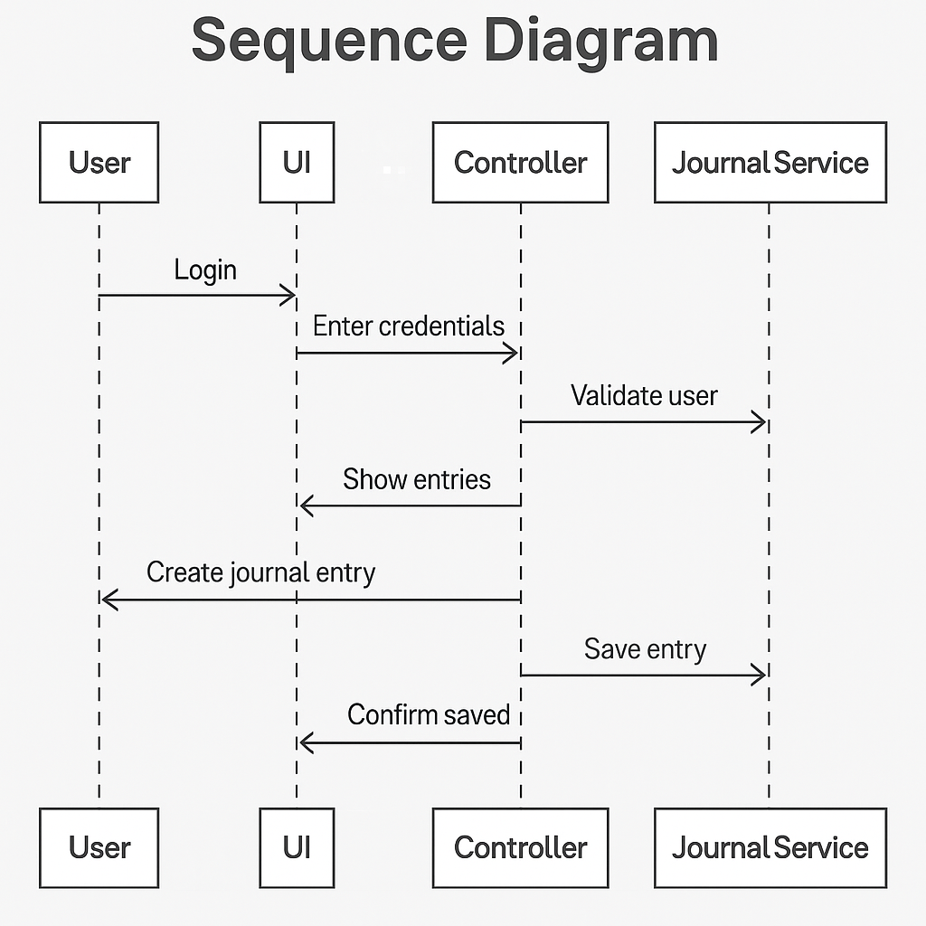

## Class Diagram

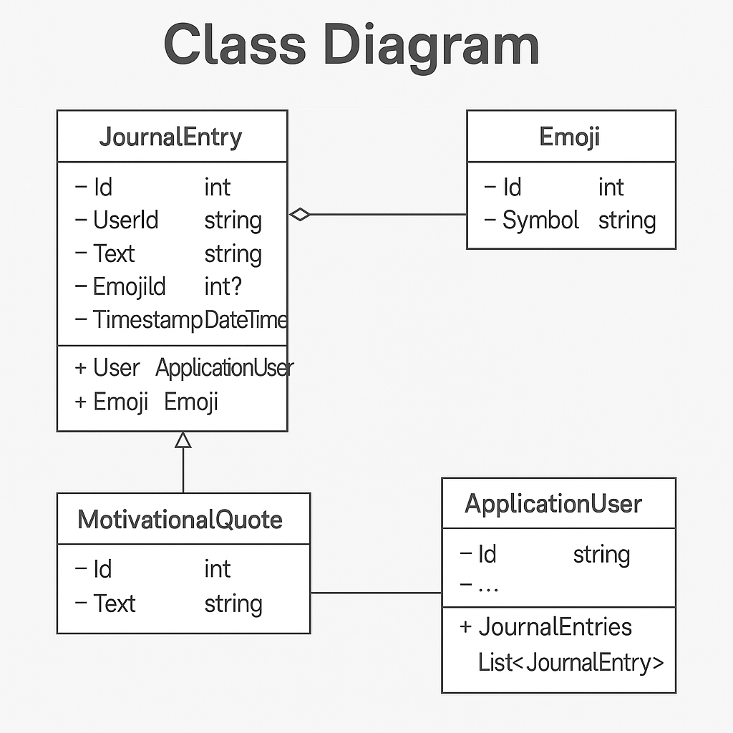

## Component Diagram

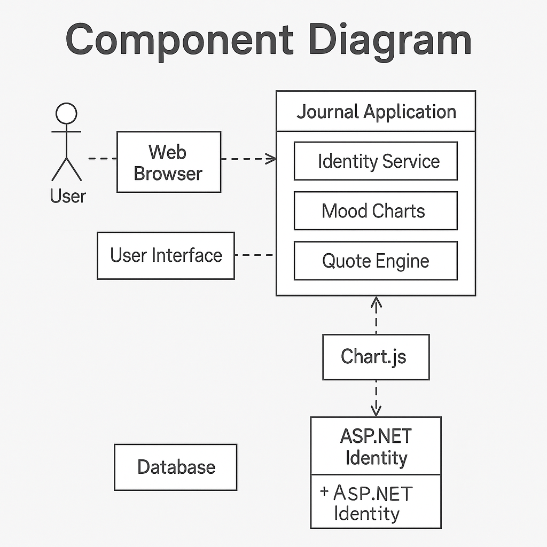

## Deployment Diagram

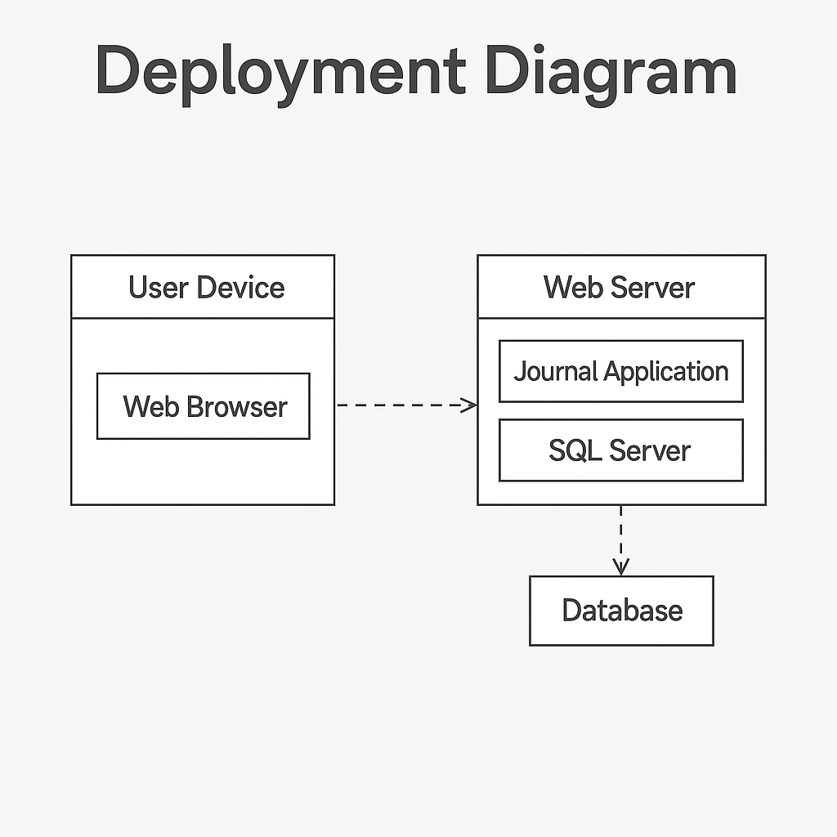

## Data Modelling

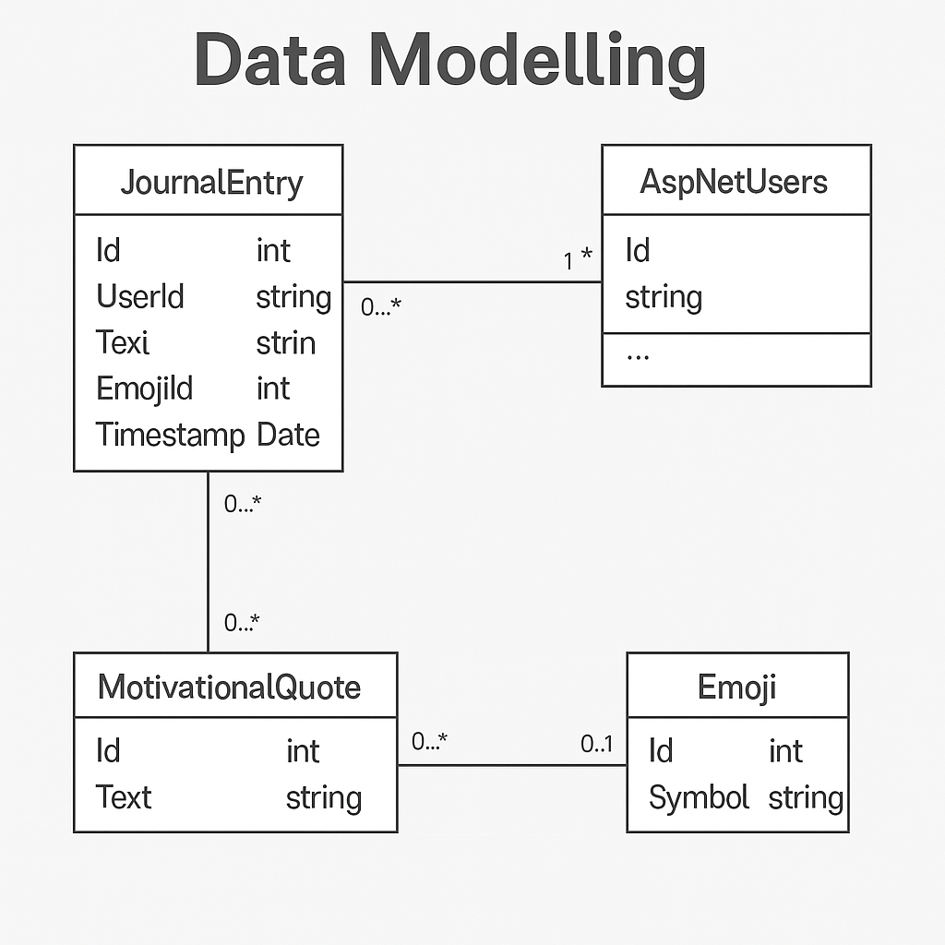

## Data Flow Diagram (Level 0 & 1)

